WeSay Documentation
Table of Contents
About This Document 3
Installing WeSay 4
Downloading WeSay 4
Running the Installer 4
Initial Setup 6
Creating A New Project 6
Writing System Setup 6
Adding an Additional Language 10
Steps to Add Additional Languages 10
Setting Displayed Writing Systems 10
Audio Recording 16
Setting up an Audio Writing System 16
Recording with WeSay 17
Controlling Fields in WeSay 19
Changing the Interface Language 21
Accessing User Interface Languages 21
Changing WeSay Tasks 23
Tasks Menu 23
Actions Menu 24
Uses for Tasks 25
Reference 27
Sorting 27
Tasks 27
Dashboard 28
Dictionary Browse & Edit 28
Add Meanings 28
Add Parts of Speech 28
Add Example Sentences 28
Add Base Forms 29
Gather Words Using the SIL Comparative African Wordlist 29
Gather Words by Semantic Domain 29
Actions 29
Email This Dictionary 30
Backup To Device 30
Export to SFM 30
Make PDF Dictionary 31
Open in Lexique Pro 31

About This Document

Installing WeSay

Downloading WeSay
The first step to installing WeSay is to get the installer. You can find this installer on the WeSay webpage by clicking on this link or copying it into your browser: www.wesay.org/downloads. In this index, click on the most recent WeSay update. There are two versions of WeSay for you to choose from – WeSay.0.4, which is the stable version, and WeSay.0.5, which is the developer's version. This version has more features but also more bugs.
To find the right file, look for a name like 'WeSayInstaller.0.4.1767.msi' that has a size of roughly 6.0 – 7.0 M and the description 'WeSay Installer'.
Check the WeSay website, www.wesay.org, for more information about this product.

Running the Installer
After you've clicked on the link, select download and wait for the file. Once the file has finished downloading, double-click on the icon to start the setup. You should see a pop-up appear like the one below.
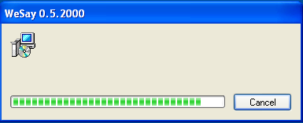
Note that there will be no setup menu asking you to confirm the installation. When the welcome text appears, WeSay will have already finished installing.
Now that WeSay is installed on your computer, you can access it through Start Menu | Programs | WeSay. In this folder, you will find four icons. The first two, 'Configure Biatah Sample' and 'Run Biatah Sample' are example dictionaries included with WeSay for reference. The other two, 'WeSay' and 'WeSay Configuration Tool' are for your use in building a dictionary.
The important program is the WeSay Configuration Tool, which allows you to decide what features and functionality the actual program WeSay will have access to.
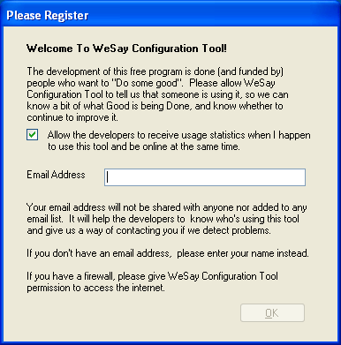
When you open the WeSay Configuration Tool for the first time, a pop-up like the one shown will ask you to give usage statistics to the developers of WeSay. Read this and decide whether or not to share your information.
Once you've done this, the WeSay Configuration Tool will open and you will be ready to being building a dictionary.

Initial Setup

Creating A New Project
When the WeSay Configuration Tool first opens, you will see a window like the following:
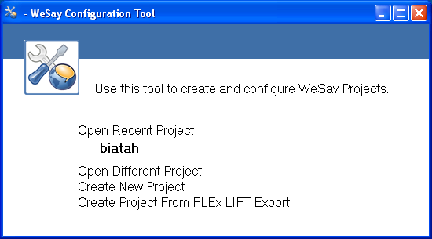
The recent project displayed is the example dictionary 'biatah' included with WeSay. You can choose to either look at the 'biatah' dictionary for reference or create a new project. To set up your dictionary, choose the latter.
WeSay will ask you for the name of your project. Typically this will be the name of the language you are making the dictionary for.
Once you've selected 'Create New Project', the WeSay Configuration Tool will go to its configuration menu and there will be a pop-up, explaining how to start using WeSay. This information will be covered later in this guide.
Your created dictionary will be stored in My Documents | WeSay after you make it.

Writing System Setup
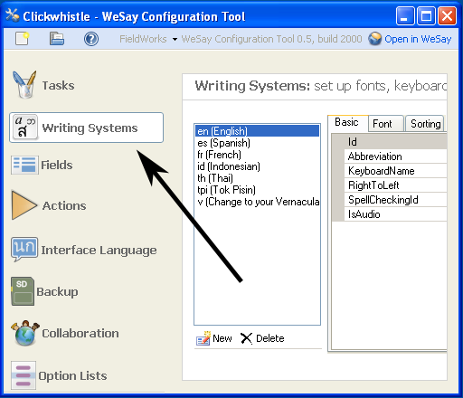
The first step to making your dictionary is to choose the writing system of the language you are going to be working with. For this, click Writing Systems on the bar on the left of the window.

In this example, the name 'Clickwhistle' in the upper left-hand corner is the name of the project.
In this menu, you can see seven possible writing systems, starting with the selected – English. At the bottom of this list is the template writing system you can use to make your own system to use in the dictionary. It's the one abbreviated 'v'. Click on this line to start making your writing system.
The menu should then look like this:
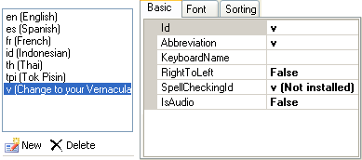
The Id is the line you need to change. The abbreviation line and the SpellCheckingId will change automatically.
Only type in the abbreviation for the system you are inputting. You won't be able to add the language name in parentheses like the writing systems already in WeSay.
Now click on the line next to KeyboardName and open the dropdown menu. If you have different languages installed on your computer, they will appear as selections in this menu. Choose which language you are going to be using for this writing system.
You can tell what languages you have on your computer by the language bar on the bottom right side of your screen. If there is no language bar, you have no additional languages installed on your computer and the KeyboardName in WeSay will use your computer's default language.
Once the language name is selected, click on the RightToLeft line and use the dropdown menu to choose which direction the language is read from. For now, as you first set up a writing system, don't worry about the IsAudio line.
Now that the basics are set up, click on the Font tab to choose what font you want your writing system to display in.
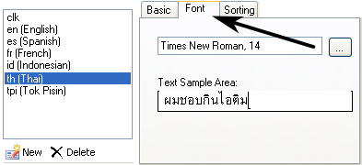
Click on the button with the dots to choose the font parameters, and use the sample area to make sure the font displays clearly. The sample can display in any language that your computer supports.
Once you have a working font chosen, you can click 'Open in WeSay' in the top right corner of the WeSay Configuration Tool and start working on your dictionary.

Adding an Additional Language

Steps to Add Additional Languages
When we decide to add an additional writing system – say, for example, we want to translate from Clickwhistle into Italian – the second writing system of Italian will not automatically appear in WeSay. We will need to manually set it to appear.
There are two steps to entering a new writing system and getting it to show up in WeSay:
- Add the new writing system in the Writing Systems menu in the WeSay Configuration Tool.
- Get the new writing system to display by configuring where it is shown in the Fields menu.
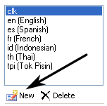
Start by going to the Writing Systems menu in the WeSay Configuration Tool. Then click the 'New' button, shown above. Now fix the settings you want for this new writing system (covered in Initial Setup).
Even though you just added this writing system, it still won't appear in WeSay in any of the text boxes. Now you have to configure the fields to display this writing system.

Setting Displayed Writing Systems
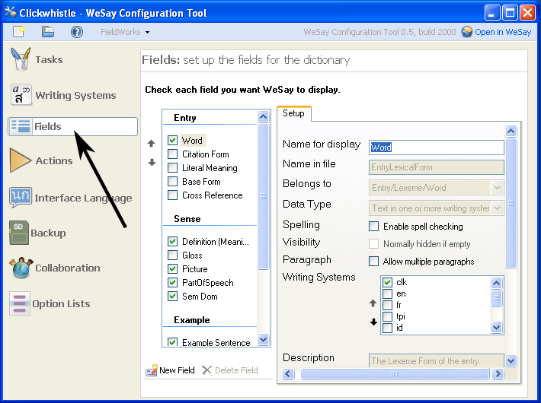
In order to set where your new language is displayed, you need to open the Fields menu, shown below.
The two important features of this menu are the Checkbox Panel – the list on the left of the menu with all the checkboxes; and the area under the Setup tab called 'Writing Systems'. You can click on any of the items in the Checkbox Panel to open its set of 'Writing Systems'. Then you can check off whatever writing systems you need in the 'Writing Systems' box.
You can do more with the Checkbox Panel. See 'Controlling Fields in WeSay' for a guide on this.
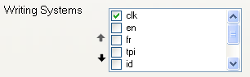
Whatever writing systems you check or uncheck in the 'Writing Systems' box will be displayed in the multi-texts* in WeSay.
This is the crucial part of the Fields menu. The writing systems checkboxes shown above have total control over what languages WeSay can use.
*A multi-text is the developers' term for the text fields used to input the different information in WeSay. An example is the field in the WeSay screenshot below used to write 'Tweet-Clack'.
In the 'Word' field of our WeSay at the moment there is only Clickwhistle ('clk') being displayed. However, if we were to check other boxes, like 'en' and 'fr', these languages would become available in the multi-text and the multi-text would look like the picture below.
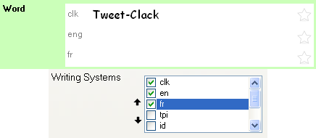
You can add these extra languages to the multi-texts of any category in your dictionary – Words, Notes, Definitions, etc. Just select different fields in the Checkbox Panel.
The new writing system we made (in our case, Italian) will always appear at the bottom of the list of Writing Systems. You can scroll down to find it, and use the black arrows beside the list to move it up the list.
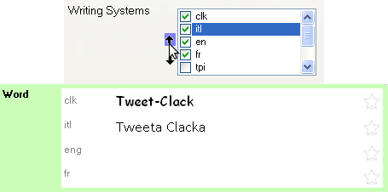
The different writing systems displayed in a multi-text will appear in the order they are shown in the selection box. Use the black arrows to put the writing systems you want at the top above the other systems.
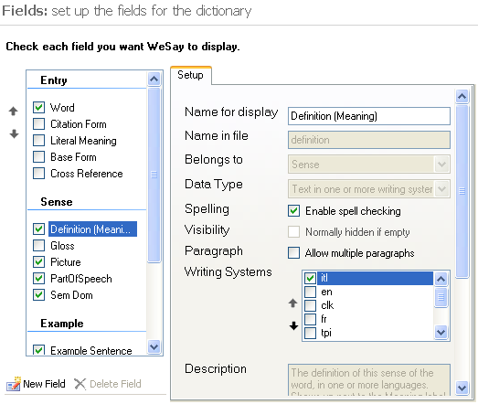
Coming back to our original intention of translating from Clickwhistle to Italian, shown above is a way we could set up the Fields menu to give us the right results.
In this form, the only fields we've changed are the Word and its Definition. The Word we've made only in Clickwhistle (clk) and the Definition we've made only in Italian (itl).
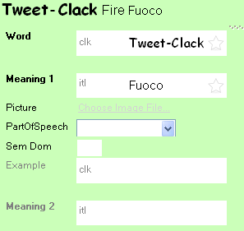
Shown below are the resulting WeSay dictionary fields. Notice how because we made the word in Clickwhistle and the definition in Italian, those are our only options for what to write under Word and Meaning.
By using the Fields menu in the WeSay Configuration Tool, you can add multiple languages to WeSay and configure the dictionary to use exactly the languages you want to use.

Audio Recording

Setting up an Audio Writing System
Once you've been adding to your dictionary for a while, you might want to start entering audio clips into your dictionary entries along with the usual words and definitions. WeSay is already configured for this. The only thing you have to do is add a new audio writing system to your dictionary.
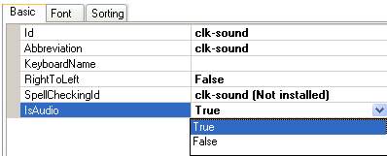
To make an audio writing system, go to the 'Writing Systems' menu in the WeSay Configuration Tool and go through the same process to make a writing system as you did before (see Initial Setup). This time, however, set IsAudio to true.
It's helpful to name your audio entries the same as their written counterpart, with either -sound or -audio on the end.
Once you have this audio writing system, go to the Fields menu to set up WeSay for recording. Like with the other writing systems, you can put your audio writing system into any of the fields in the checkbox panel, whether it's Word or Definition or Example Sentence.
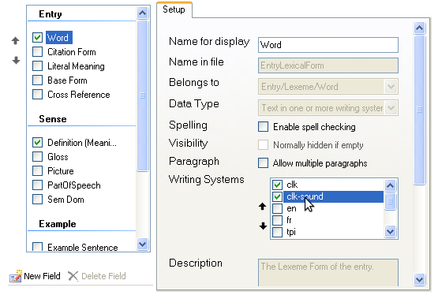
In this case we've put the audio system of Clickwhistle alongside the regular writing system, and both of these are in the Word field. That means that in WeSay we can now transcribe a word, record someone saying it, and then write its definition.

Recording with WeSay
When we go into WeSay we'll see an extra field in the Word multi-text with a button.
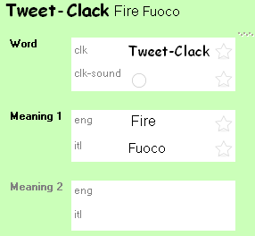
This button is used to record sounds. If you have a microphone hooked up to your computer, when you press and hold down on the button, WeSay will record the sounds from the microphone.
The record function works like a walkie-talkie. As long as you hold down on the button, the microphone records. Once you finish talking, release the button. If you just tap the button without holding down, WeSay won't record. If you hold down for a long while after you've finished talking, the recording will be very long and not very useful.
After you've finished recording there will be two buttons, as shown below – a play button (the triangle) and a cancel button (the 'x'). Pressing the play button will play your recording back to you. Pressing the cancel button will remove the recording. If you do this, the record button will re-appear and you can make another recording.
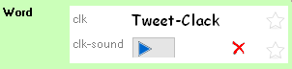
You can make as many audio writing systems as you need. Simply attach the writing systems to specific fields in the Fields menu and you can record as much as necessary in WeSay.

Controlling Fields in WeSay
You can control what entries will appear in WeSay by using the Fields menu in the Configuration Tool. Once in the Fields menu, look at the Checkbox Panel on the left of the screen.
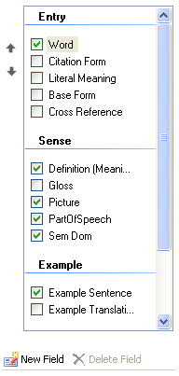
Any of the checked boxes will show up in WeSay when you open it. For example, if you unchecked 'Definition' and checked 'Base Form', then when you opened WeSay again, there would be no line for the meaning of the word, but there would be a new line for the base form.
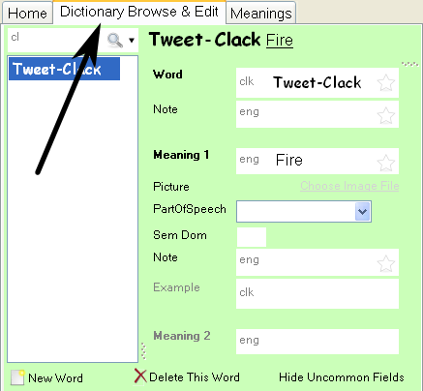
You can further change the lines in WeSay using the Writing Systems panel. See 'Adding an Additional Language' for information on this.
You can see what fields you are showing by opening WeSay and going to 'Dictionary Browse & Edit'. Any changes you make in the Configuration Tool will be displayed in this dictionary window.

Changing the Interface Language

Accessing User Interface Languages
The language of the user interface in WeSay can be easily changed in case a non-English speaker needs to use the program. Just go to the Interface Language menu in the WeSay Configuration Tool.
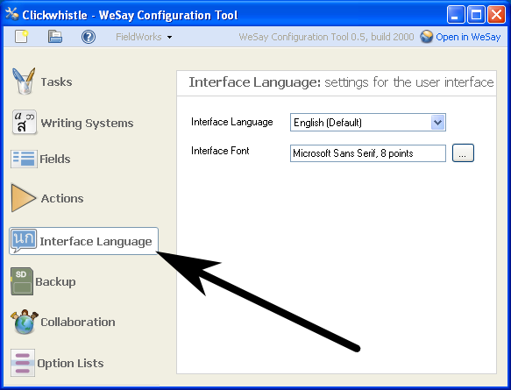
In this menu you can choose what language WeSay will be in using the 'Interface Language' dropdown list. You can also select different fonts in order to maximize the clarity of the languages you use, including choosing larger fonts to be easier to read as shown below.
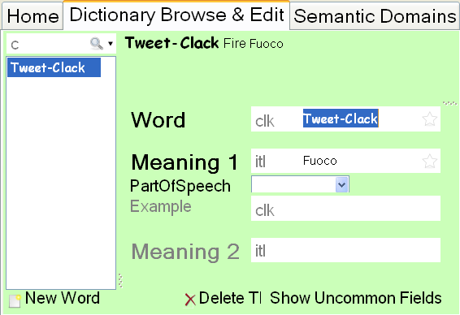
However, notice that the changes in font size only apply to the menu words in WeSay, not the words entered into the dictionary.
The changes you make to the language will only affect WeSay and not the WeSay Configuration Tool.

Changing WeSay Tasks

Tasks Menu
When you first open WeSay you'll see three options – 'Semantic Domains', 'Dictionary Browse & Edit' and 'Backup', each under a different heading – 'Gather', 'Describe' and 'Share', respectively. However, WeSay is capable of performing more tasks than these. There are seven other tasks that WeSay can undertake which you can enable in the WeSay Configuration Tool.
Five of these other tasks can be found in the Tasks menu, as shown below.
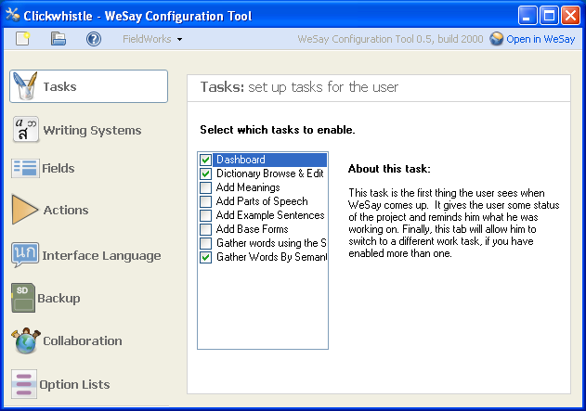
The first in the list, 'Dashboard', is the default menu you see when you open WeSay. The other two check-marked boxes are two of the options in WeSay.
The third option usually seen in WeSay, 'Backup', is found in the Actions menu and will be discussed shortly.
The other five unmarked boxes are possible options you can put in WeSay. If you check any of the boxes, then when you open your dictionary again they will be available on the opening screen. Likewise, if you uncheck any of the current boxes, they will no longer appear in WeSay.
You can look through the individual tasks to see what they are each for, or you can check the reference in this documentation for descriptions.

Actions Menu
The Tasks menu has five out of the seven possible options you can add to WeSay. The other two, and the already enabled 'Backup', can be found in the Actions menu, as seen below.
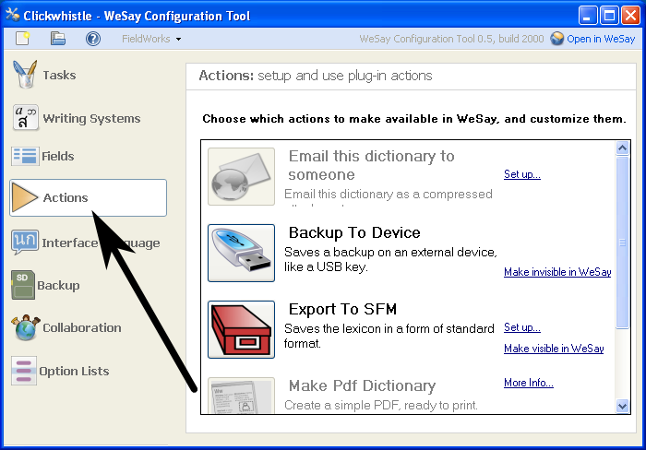
The Actions menu has several options. You can configure three of these to appear in WeSay – the Emailing, Backup, and Export options. Two other options are also available: Making a PDF and using Lexique Pro. All of these options in the Actions menu will require time to set up, whereas the Tasks menu has options that work as soon as you select them.
Explanations for the selections in the Actions Menu are also available in the reference. You can also get information by clicking next to each option on either the 'Set up...' or 'More Info...' buttons.

Uses for Tasks
By setting up the tasks differently, you can change the entire functionality of WeSay. This is useful for group projects where each member contributes a different part of the dictionary. You can change WeSay with the Configuration Tool so that each person can see the parts of the dictionary they need to add to, without being bogged down by a multitude of buttons.
For instance, in a project we could start by only adding in words. We might want to use the Semantic Domain to give us prompts, so we will disable everything except the Semantic Domain. WeSay would then only have one button to press.
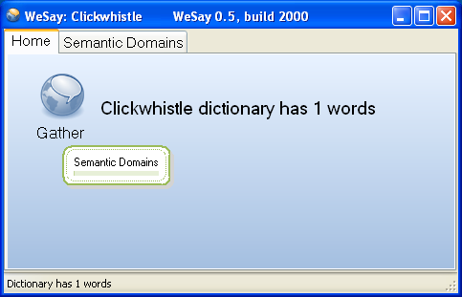
We could then give a computer with this WeSay to someone and have them go through and add in words through the Semantic Domain. Once we had enough words, we might want to put in the meanings of these words and so we could disable the Semantic Domain and turn on the Add Meanings function.
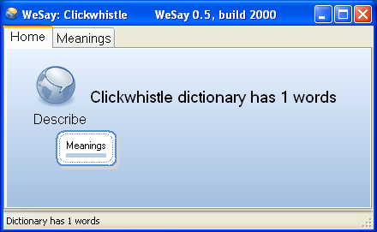
The next person to use WeSay would then only have the ability to add in meanings to the words in the dictionary. We could continue focusing the abilities of WeSay in this manner until we had made a dictionary and filled in all the entries. WeSay is capable of focusing solely on words, definitions, parts of speech, example sentences and base forms.
The different, focused areas of WeSay are mostly useful as uncomplicated means to add to a dictionary. The 'Dictionary Browse & Edit' function is capable of everything the other buttons are, and more.

Reference

Sorting
If the language you are working on has an alphabet with a peculiar ordering of letters, you can set WeSay to recognize this in the 'Sorting' tab under the Writing Systems menu.
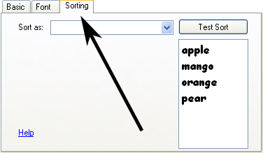
Use the dropdown menu to select a system to sort your language. If none of them fit, you can use either of the two custom sort methods at the top of the list to set up your letter order. Type different words into the box on the right to test your alphabet sorting order.

Tasks
There are eight total tasks that can be selected in WeSay, shown below. They are explained in the Configuration Tool, but you can read explanations here as well.

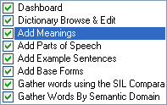
Dashboard
The dashboard is the first menu that appears when WeSay is opened, which means you can't turn it off. It is the point of access from which you can select any of the other options you have configured WeSay to use. It also tells you the name of your dictionary and the number of words you have collected.

Dictionary Browse & Edit
This tool is used to search through all of your dictionary entries to find certain words and edit any incompletions. The search function in the dictionary finds words based on similarities, not exact matches, so if you type in an approximation of the word you are looking for, the search engine will find the exact word. You can use 'Dictionary Browse & Edit' to delete words, look up words and edit words, but note that this tool is not intended as the primary way to add new words to the dictionary.
There is a 'Show Uncommon Fields' button in the 'Dictionary Browse & Edit' window that is used to avoid cluttering the page with unused fields. Fields can be set as uncommon (invisible) in the Fields menu in the WeSay Configuration Tool.

Add Meanings
The 'Add Meanings' tool allows you to scroll through your entire dictionary and add definitions to any words that lack them. You can also use the WeSay Configuration Tool to set the 'Add Meanings' function to only add definitions to words that lack definitions in specific languages, or already have definitions in certain languages. In this tool you can scroll through a list of all words lacking meanings with Page Up and Page Down, and enter a definition with Enter.

Add Parts of Speech
This tool enables you to go through a list of your dictionary words that lack identifying parts of speech and add them in. Use Page Up and Page Down to scroll through the words and use the dropdown menu to select the corresponding part of speech.

Add Example Sentences
The 'Add Example Sentences' function allows you to scroll through all of your dictionary entries that lack example sentences and add them in. You can use the WeSay Configuration Tool to sort by writing systems present or absent. Like with the other tools, 'Add Example Sentences' uses Page Up and Page Down to scroll through the entries, and Enter to add an example sentence to the dictionary. This tool also includes the option to add a translation of the example sentence.

Add Base Forms
The 'Add Base Forms' tool is a means to go through all dictionary entries that don't have base forms entered and either add a base form or identify the word as lacking a base form. This tool uses Page Up and Page Down to scroll through the words and Enter to add the base form.

Gather Words Using the SIL Comparative African Wordlist
This tool is a collection of 1700 English words gathered by SIL that you can scan through and add words in another language for. Use Page Up and Page Down to scroll through the words, and type the word and press Enter to add a word. You can add multiple entries for each word in the database. Later on you can go through and put in definitions for these words separately.

Gather Words by Semantic Domain
This tool allows you to go through a comprehensive list of Semantic Domain definitions and input words in another language. The new words that you write will be tagged with the Semantic Domain number they were identified by, and you can also choose to tag the words with a short definition. The definitions in the Semantic Domain include brief questions to help define the word. Use Page Up and Page Down to scroll through the questions in the Semantic Domain, or find the Semantic Domain number you are looking for in the dropdown menu. Use Enter to input words to your dictionary.

Actions
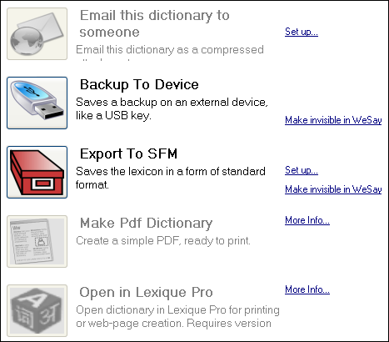
There are five possible actions to select in the WeSay Configuration Tool, shown below. All of these actions require some setup and are for use in storing, sharing or processing your dictionary, rather than building more entries. The Configuration Tool features some explanations of these functions, but you can read explanations here as well.

Email This Dictionary
You can use this tool to email your entire dictionary to someone else, provided you have a working email address. Click 'Set up...' to enter the recipient's email address, and then you will have the option to make the button visible in WeSay. Once the button is in WeSay, you can click it to send your dictionary. WeSay will ask you for your name, email address and then information about your email server. After you enter this information, you will be able to send your dictionary through email.

Backup To Device
This tool will back up your entire dictionary onto an external device, provided you have one plugged into your computer. You can make the button for this visible or invisible in WeSay. When it's visible, if you have a device like a thumbdrive plugged into your computer, you can press the button to back up your dictionary.

Export to SFM
This is a method of saving your entire dictionary in a standard form that was previously used in Toolbox. If you click 'Set up...' you can change the languages that this export will use, as well as entering exceptions and rules. You can also toggle the visibility of this button in WeSay. When the button is in WeSay, if you click it a text document will pop up containing your entire dictionary in SFM format, with the appropriate tags in place.

Make PDF Dictionary
This option converts your dictionary to a PDF, which makes it much easier to print. To do this you will need the PrinceXml engine (for more information visit www.princexml.com or www.wesay.org/wiki/MakePdfDictionary). You can use PrinceXml free unless you are intending to use your dictionary for commercial use, in which case you will need to purchase a license. Note that this feature is not for final publication, but is intended as an easy way to print out your dictionary as you are building it.

Open in Lexique Pro
This tool is a way to set up your dictionary for the internet or for print. It is a completely free program but you will need to download version 3 or later from www.lexiquepro.com/test.htm. Lexique Pro is for Windows only, and its button will become available in WeSay after Lexique Pro is downloaded.
Things to Ponder
??? Multi text might be too much jargon. But, then again, it's a neat concept so maybe it deserves it's own section earlier in Fields.

